**R-Lab 4**  
**1. Descriptive Statistics using R:**1. R provides a wide range of functions for obtaining summary statistics. Possible functions include:  
  
**sum:** compute sum (total)  
**mean: compute mean   
sd: compute standard deviation   
var: compute variance   
min: compute minimum data value   
max: compute maximum data value   
median: compute median   
range: compute range   
quantile**:compute quartiles/percentiles/deciles

**Note: *Everything in red is typed by the user. Everything in blue is output to the console.***

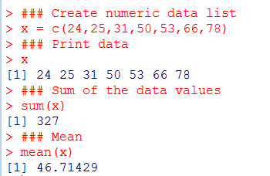

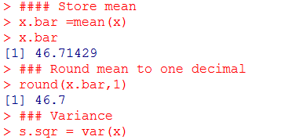  
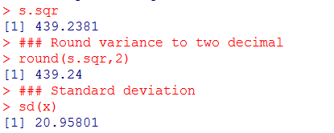

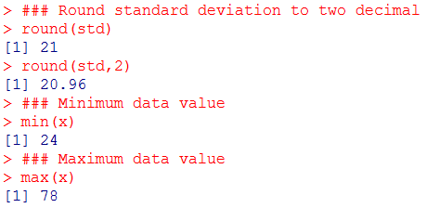

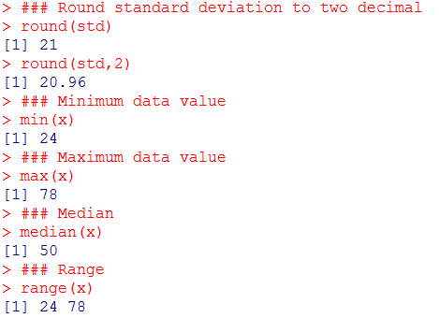

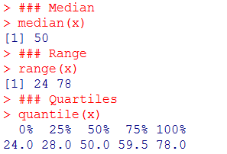

2. There are also numerous R functions designed to provide a range of descriptive statistics at once. For example:

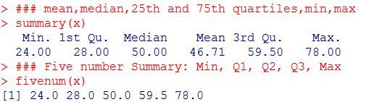

**2. BOX-PLOT :** Is/are created with the boxplot( ... ) command.

**# Simple box-plot**  
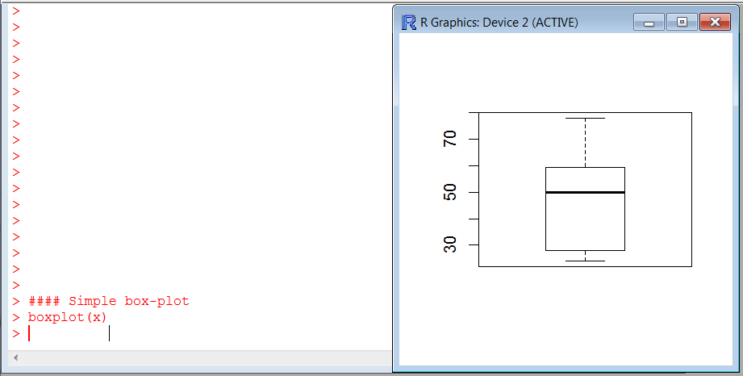

**#Adding title, x-axis & y-axis labels etc….**  
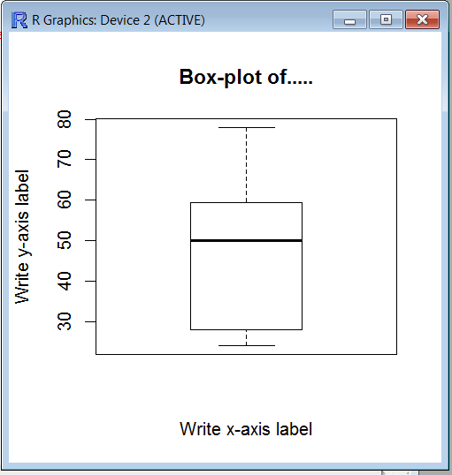

**3.** **rbind() & cbind()**:   
  
Take a sequence of vector, matrix or data-frame arguments and combine by columns or rows, respectively.   
  
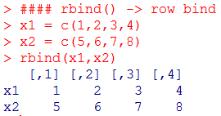

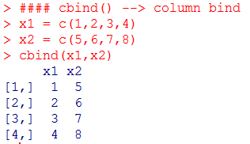

**4. Create a matrix of the data**  
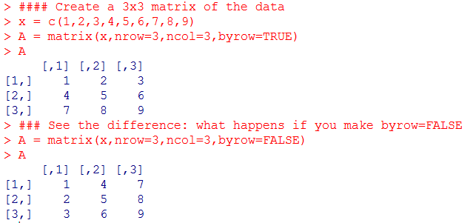  


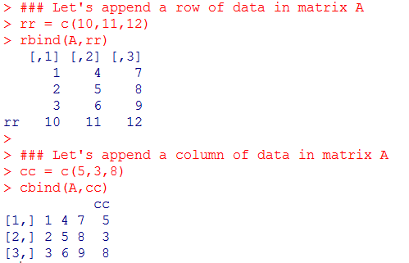

**Example:** **Making a Table (matrix):** Suppose you want to make a table of 5-numbers for each of the first three days of the work-week.  
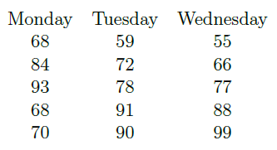  
You can combine lists like the one described above into a table using the matrix command. Setting this up takes a little effort and the usage is depicted in the screenshot on the next page.   
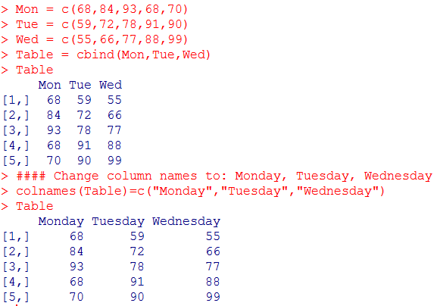

**##### OR: you can do this alternative way ########**  
  
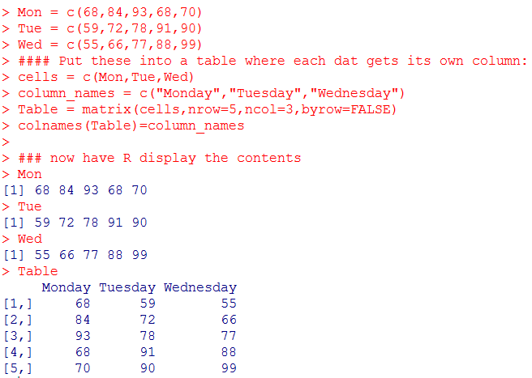

**1. Descriptive Statistics On a Table:**

All of the above functions can be applied to a table with the **apply** command.

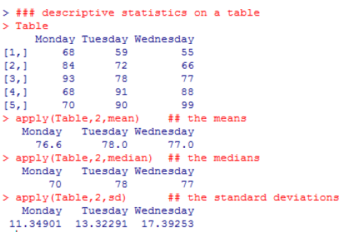

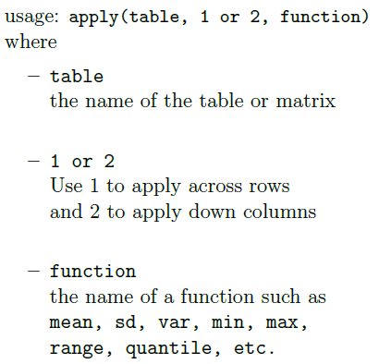

**2. The 5-Number Summary & Mean:** You can get a 5-number summary with the mean included (as a bonus) of a single set of data or a table of data using the summary command.

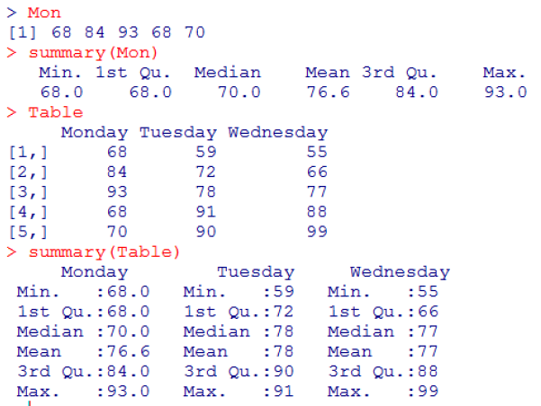

**3. Box-plot**  
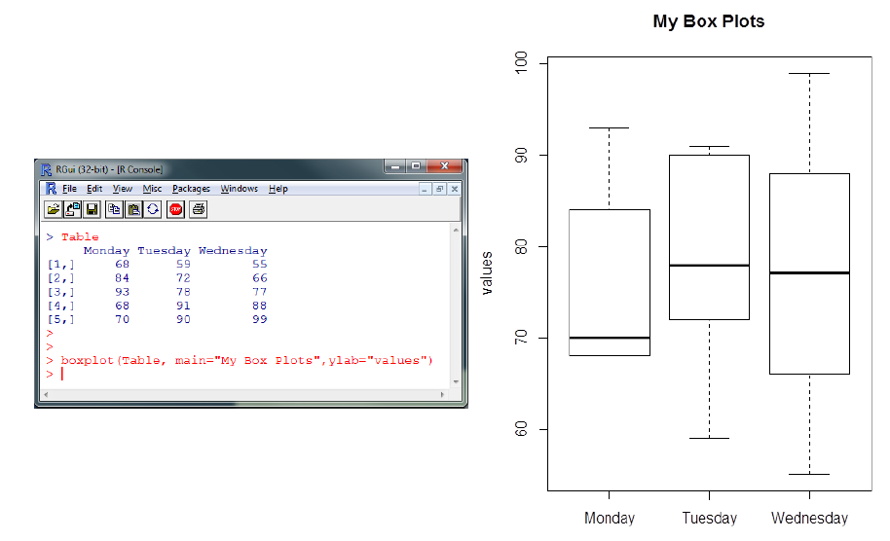

**Example 2:** Let us use the data file that we used in Lab 3. The data file is “mpg.csv”.  
  
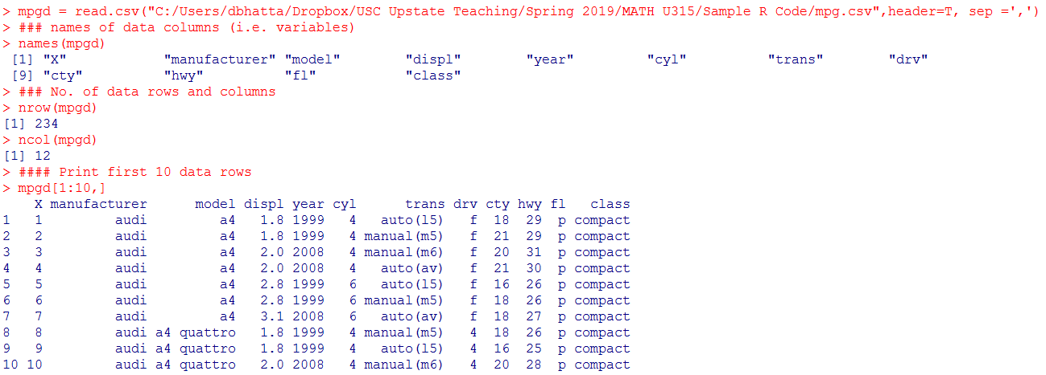  
  
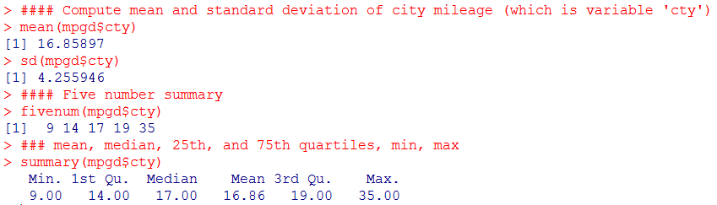

**###### Box-plot of numeric variable by grouping (categorical) variable**

  
  
